IMAS SQL
Tutorial 1a

In the following set of questions you are asked to create and populate tables holding information about clinic sessions. Below is a partial ERD from a previous tutorial. We are going to construct a database that corresponds to this ERD below:

ERD
Doctor
Nurse
Clinic Session

1..1
1..1

assigned to
attends
Clinic

1..1
has
0..*
0..*
1..*

The tables you create must (at a minimum) contain the following attributes:

Nurse:
NurseNo text(4) Primary Key
Name text(30)

Doctor:
DoctorNo text(5) Primary Key
Name text(30)
Specialism text(20)

Clinic:
ClinicNo text(4) PrimaryKey
Clinic Description text(30)
MaxNoOfPatients number

ClinicSession:
ClinicNo text(4) Foreign Key AND Part of combined Primary Key
ClinicDate date Part of combined Primary Key
RoomNo text(4)
DoctorNo text(5) Foreign Key
NurseNo text(4) Foreign Key

We are going to create a new database called Surgery

Remember you can only create 1 table at a time in Access SQL so each piece of DDL code needs to be executed separately.

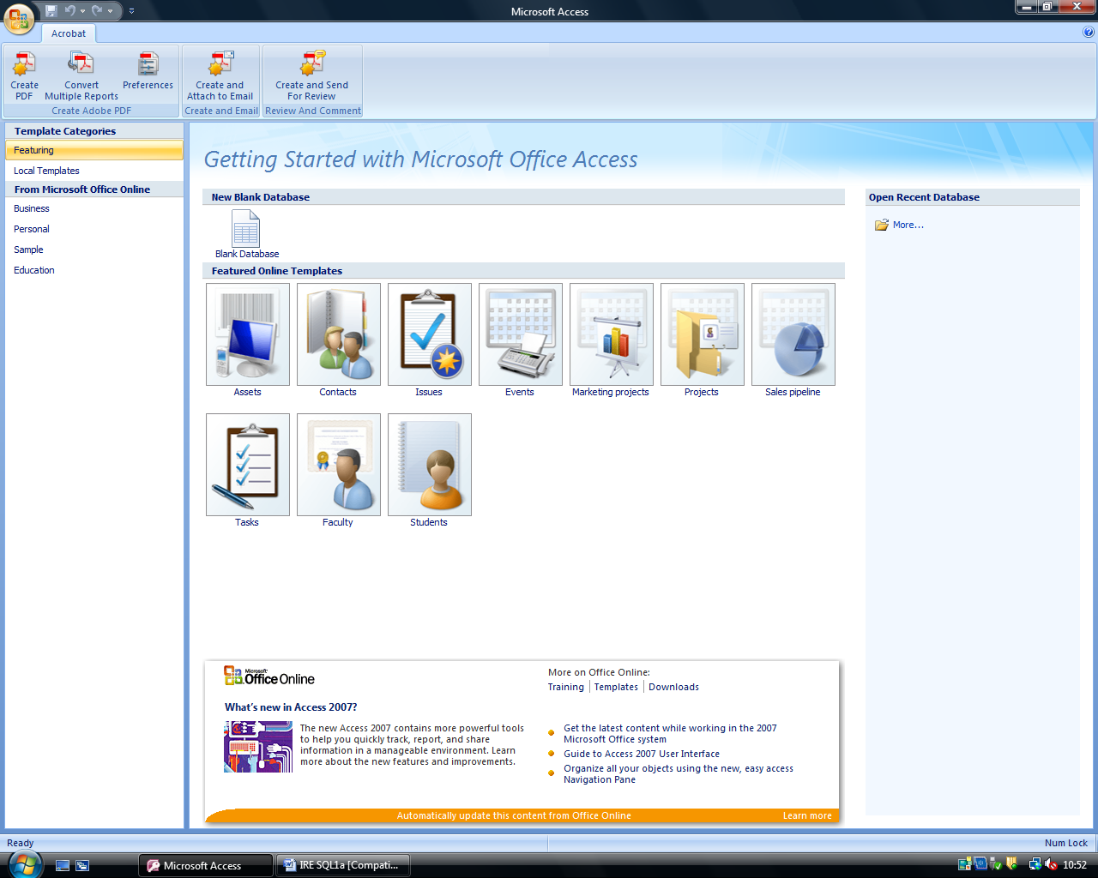
Click ‘Blank Database’

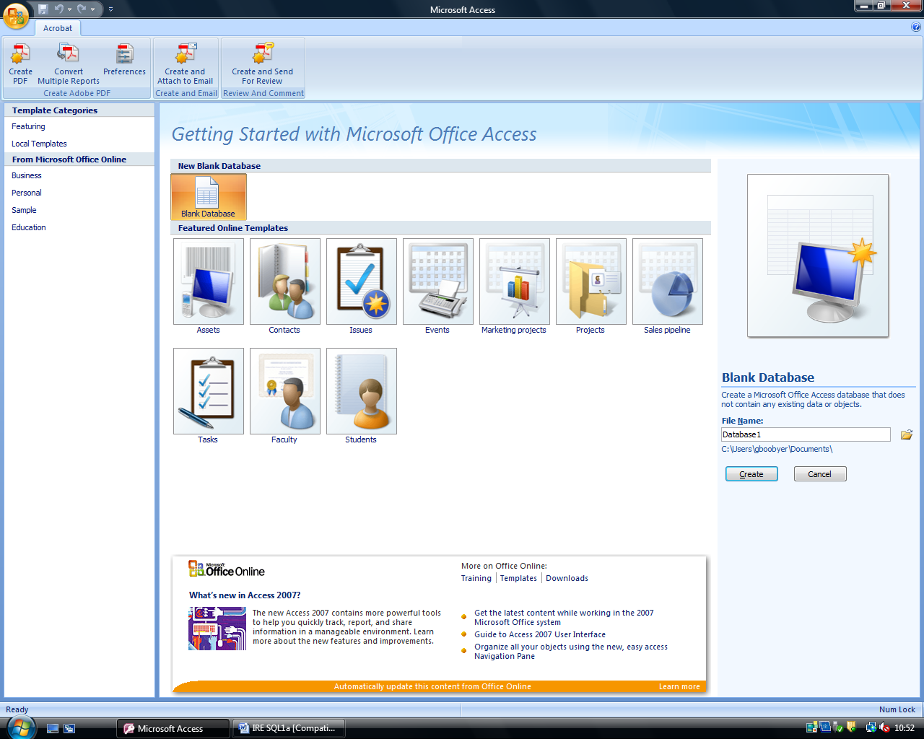
This takes you to this screen

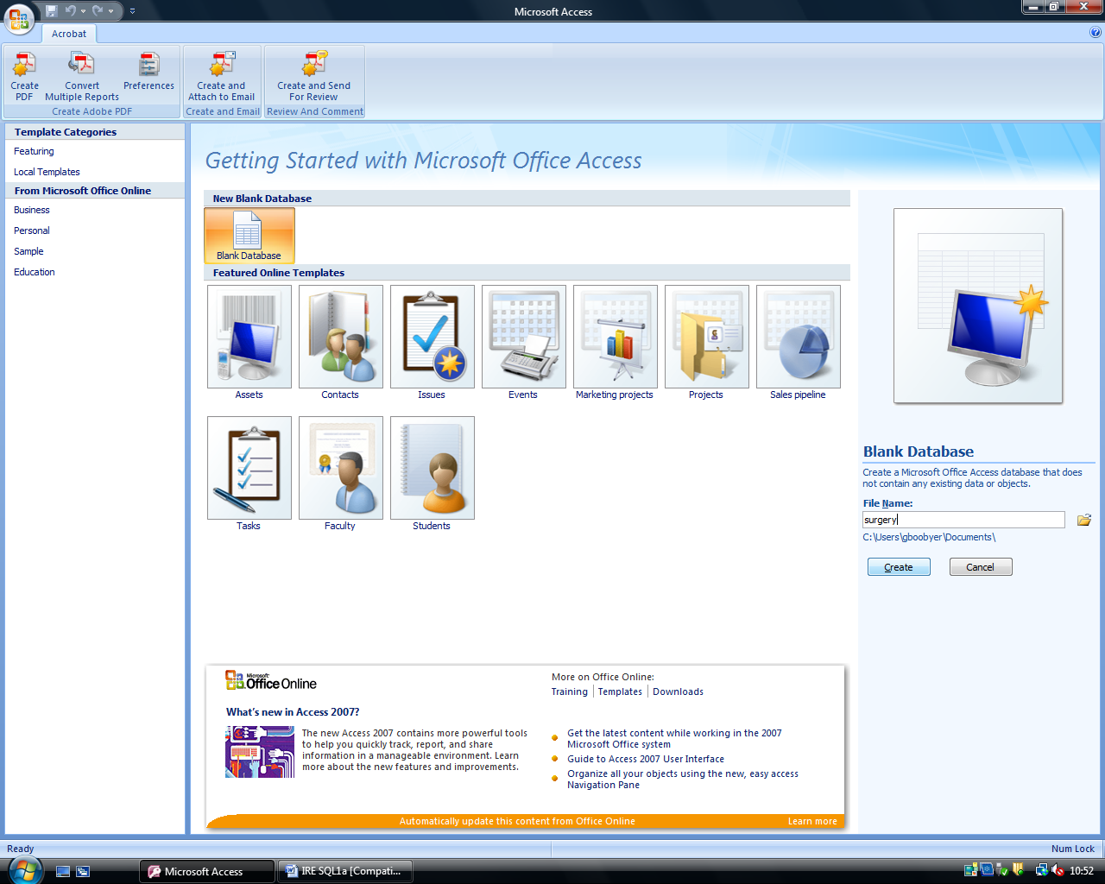
Type in your database name : Surgery in the space below File Name

Then click on the ‘Create’ button


This brings you to this screen.

Click on the Create tab


This seems the same, but you have a new menu across the top.

Click on Query Design

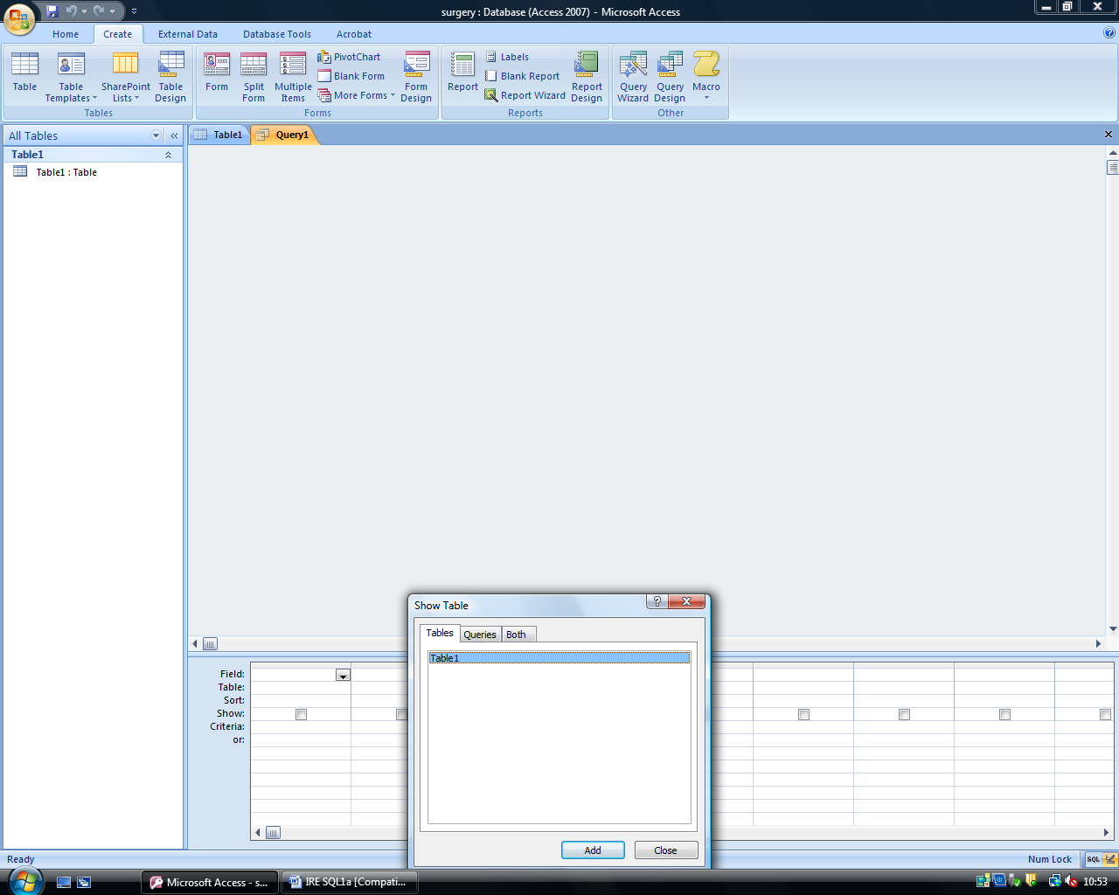
This box will appear.

Just click on Close


Just click on SQL View


Then type in the following code:

CREATE TABLE Nurse
(NurseNo varchar(4) NOT NULL,
Name varchar(30) NOT NULL,
CONSTRAINT Nurse_NurseNo_pk PRIMARY KEY (NurseNo));


Once you have typed in the code, click on the ‘Exclamation mark’ Icon to ‘run’ the code and create the table.

If you have typed in the code correctly then the table Nurse should have been created.

If not, ask tutor for help.

Using the above, (from page 4 – do not create a new DATABASE), try to create the following table using the given DDL SQL:

CREATE TABLE ClinicSession
(ClinicNo varchar(4) NOT NULL,
ClinicDate date NOT NULL,
RoomNo varchar(4) NOT NULL,
DoctorNo varchar(5),
NurseNo varchar(4) NOT NULL,
CONSTRAINT clinic_session_pk PRIMARY KEY (ClinicNo,ClinicDate),
CONSTRAINT Clinicsess_Clinic_fk FOREIGN KEY (ClinicNo) REFERENCES Clinic(ClinicNo),
CONSTRAINT Clinicsess_Doctor_fk FOREIGN KEY (DoctorNo) REFERENCES Doctor(DoctorNo),
CONSTRAINT Clinicsess_Nurse_fk FOREIGN KEY (NurseNo) REFERENCES Nurse(NurseNo));

Why does Access not allow you to create this table?

Ask Tutor for explanation before moving on to Tutorial 1b

